**LESSON 2: SEARCH (PATH PLANNING)**

**LESSON 2.2 About this lesson**

**Cost functions** and how to include human insights (like "it's easier to make right turns than left turns") into our planning algorithms.

**Optimality** and the tradeoffs associated with finding *the best* solution vs finding a solution that is *good enough*.

**Online vs Offline algorithms** and how we can avoid complex computation on the road by precomputing best paths whenever possible.

**LESSON 2.3: Motion Planning**

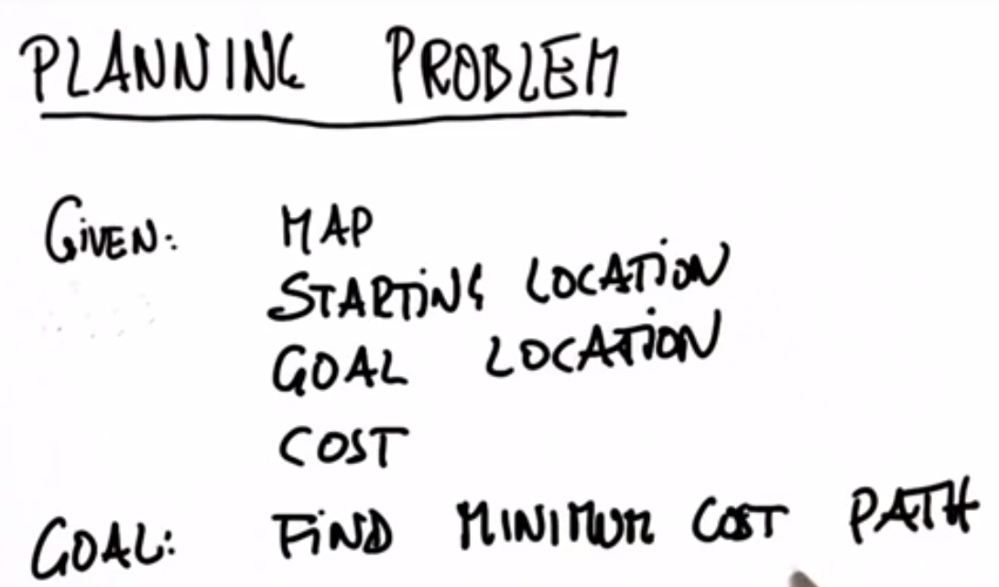

**LESSON 2.10: Quiz: First Search Program for Path Planning, Expansion Grid**

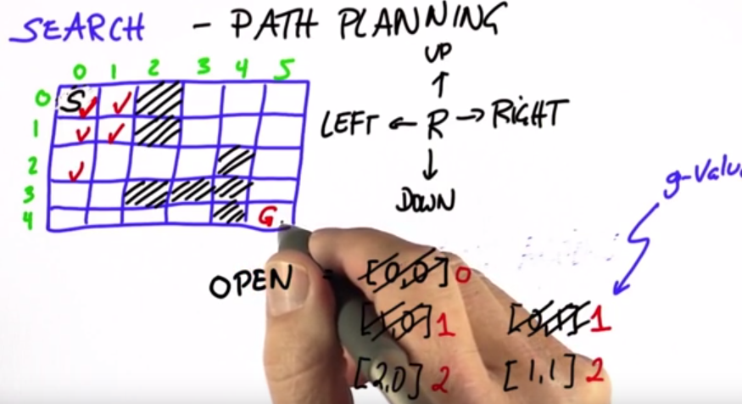

KEY: Always expand node with the smallest g, where g is the cost to get there.

**LESSON 2.12: Store actions to calculate path at end**

Keys to path planning:

* Always expand the open cell with lowest cost
* When a cell is expanded, store the last action that got us there
* At end, path can be re-calculated by walking backwards.

**LESSON 2.13: A* : Use Heuristic Function to guide choice**

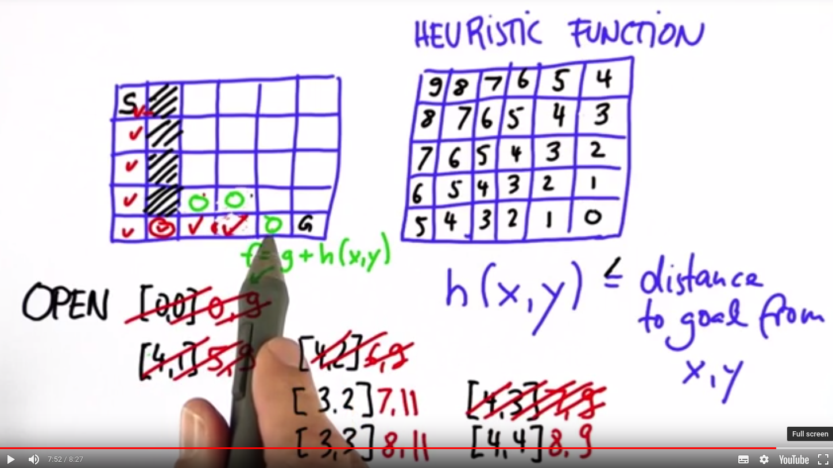

**LESSON 2.16: Dynamic Programming (Alternative to A*)**

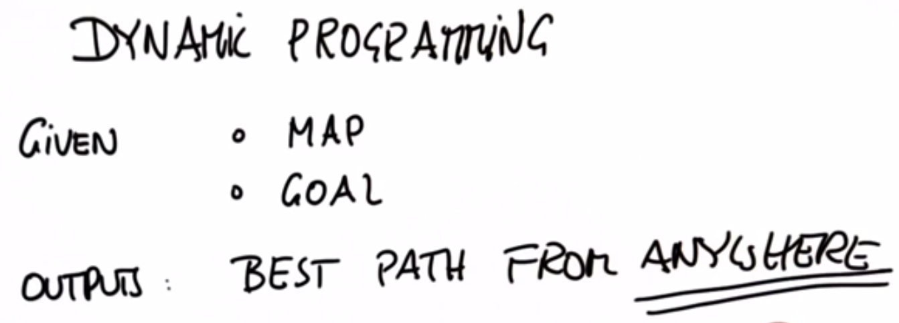

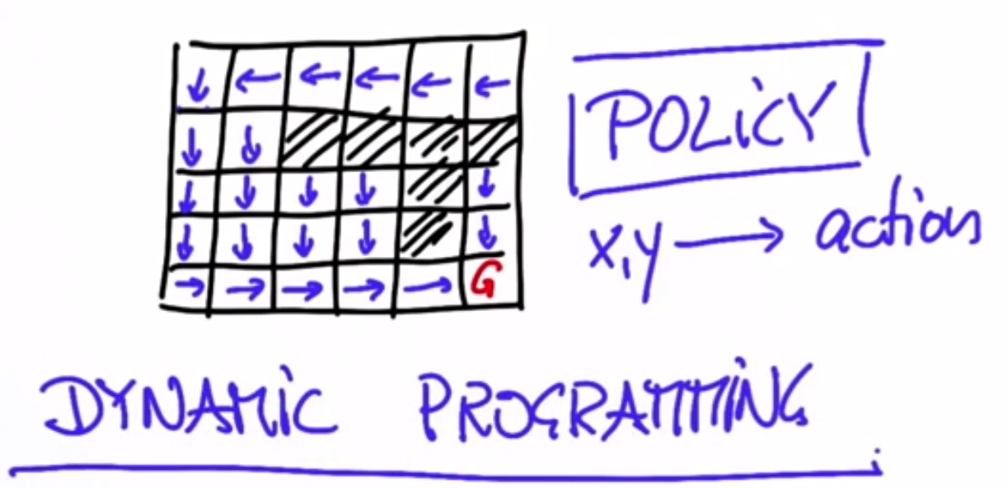

**LESSON 2.17: Computing Value**

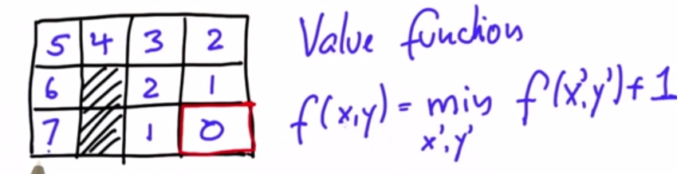

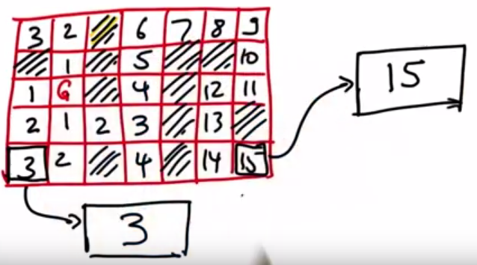

**LESSON 2.20 & 2.21: Optimum Policy & Left Turn Policy (3D)**

In Dynamic Programming (DP), for every location, the optimum policy is determined:

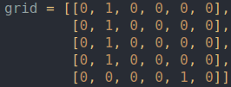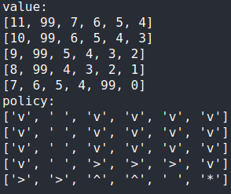

**LESSON 2.21: Optimum Left Turn Policy (3D)**

In Dynamic Programming (DP) with orientation information, for every location & orientation, the optimum policy is determined. Then, from a starting location, the policy is run to get the optimal path, stored in a policy2D list:

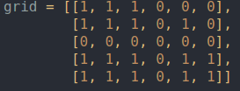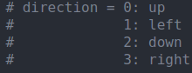

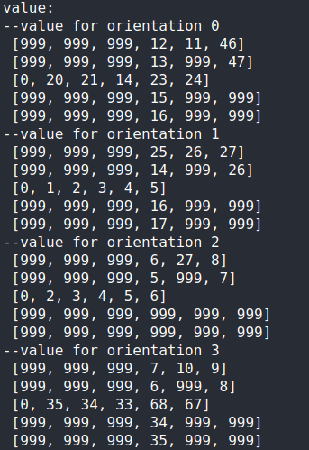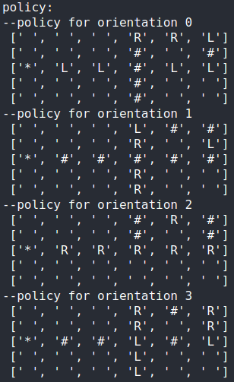

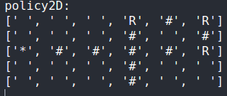When starting at (4,2):

**LESSON 2.22: Planning Conclusion**

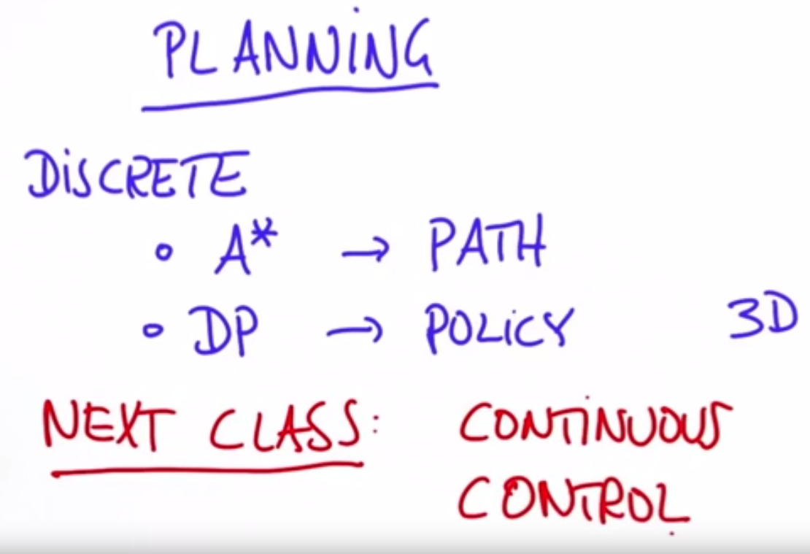**LESSON 3: PREDICTION (where moving objects will go)**

**Reference Paper:** [**https://d17h27t6h515a5.cloudfront.net/topher/2017/June/5953fc34_a-comparative-study-of-multiple-model-algorithms-for-maneuvering-target-tracking/a-comparative-study-of-multiple-model-algorithms-for-maneuvering-target-tracking.pdf**](https://d17h27t6h515a5.cloudfront.net/topher/2017/June/5953fc34_a-comparative-study-of-multiple-model-algorithms-for-maneuvering-target-tracking/a-comparative-study-of-multiple-model-algorithms-for-maneuvering-target-tracking.pdf)

**LESSON 3.1 Introduction and Overview**

Example of car at intersection: Use probability on where we expect vehicle will be in time:

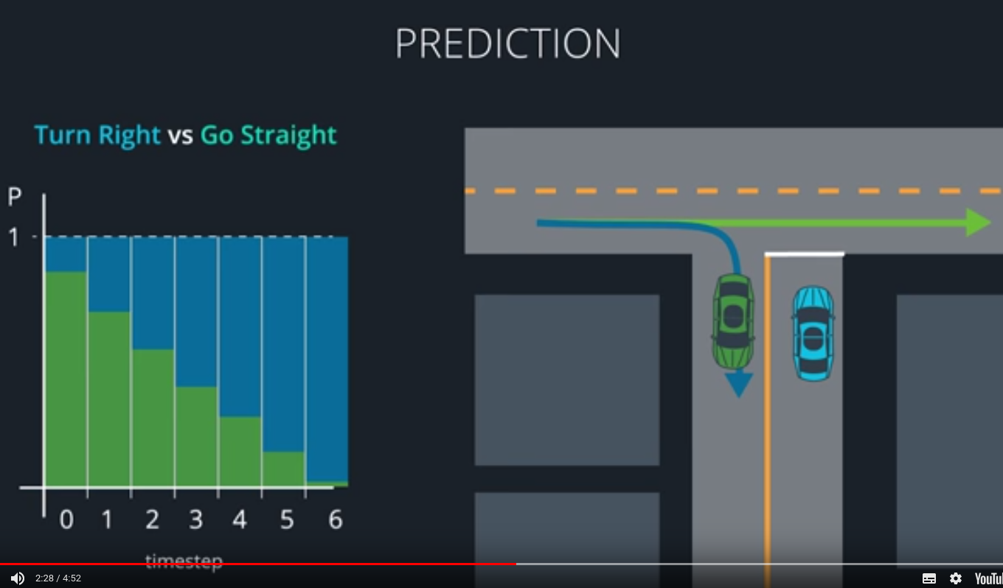

Prediction module creates trajectories for each object, with associated probability.

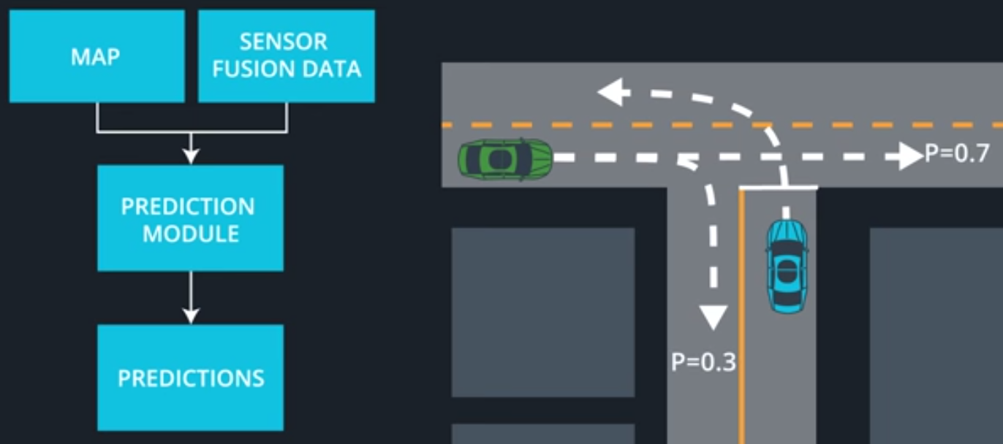

In this lesson, we will cover:

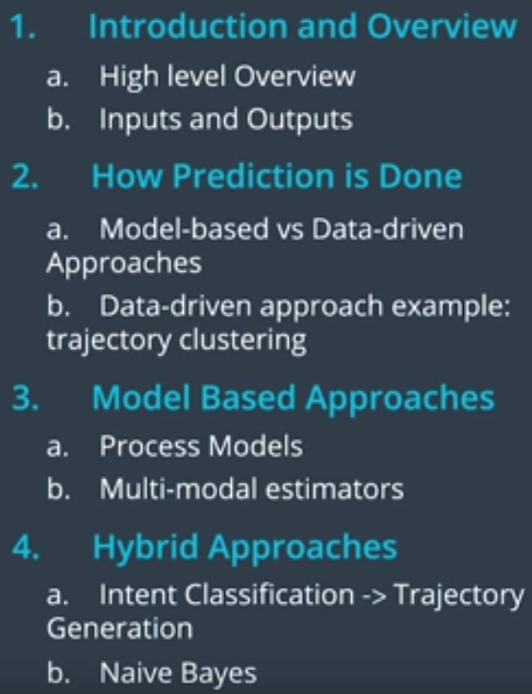

**LESSON 3.2 I/O Recap (Input to and Output from Prediction Module**

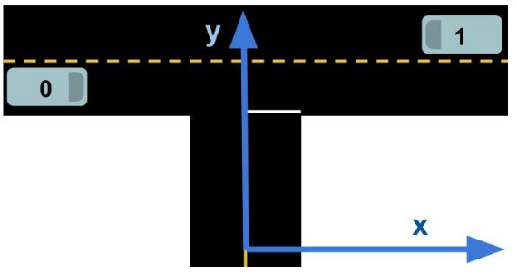

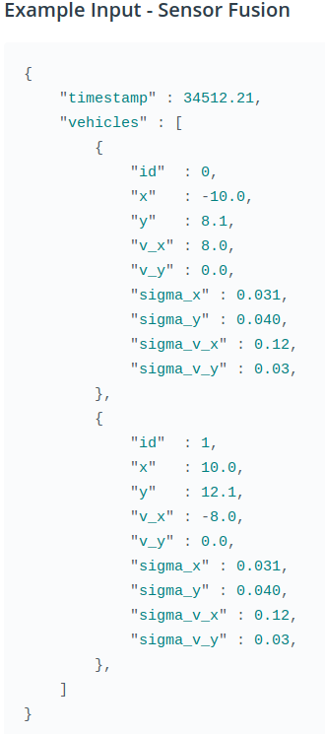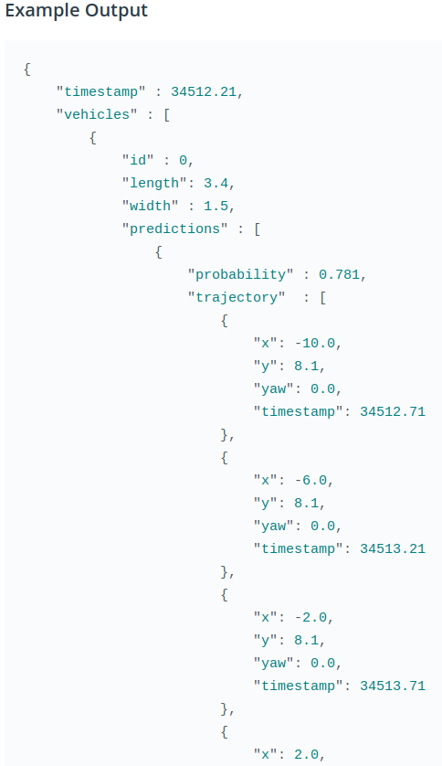**Example Input & Output in JSON format**

**LESSON 3.3: Model-Based vs. Data-Driven Approach**

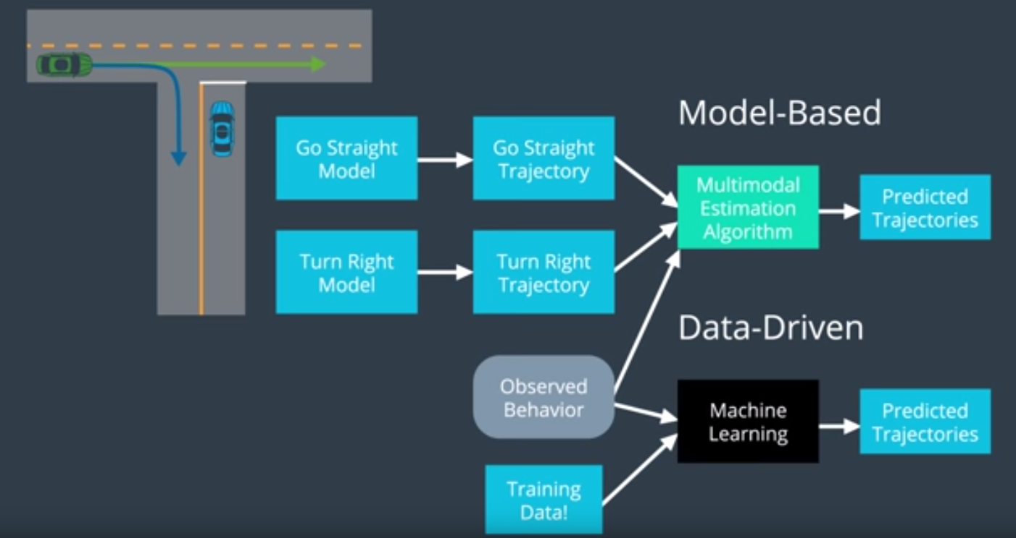

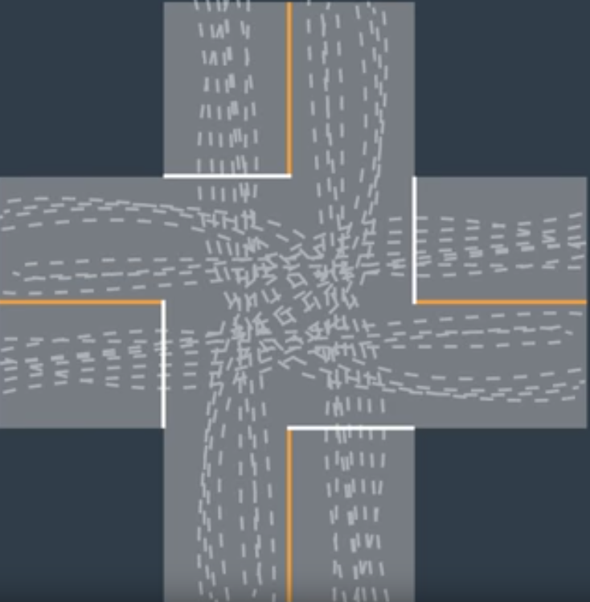**LESSON 3.5: Data Driven Example: Trajectory Clustering**

OFF LINE TRAINING

1. Get a LOT of trajectories

2. Clean the data

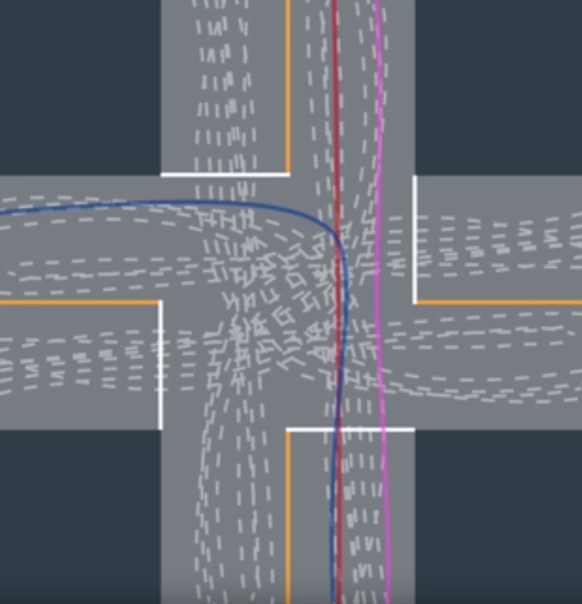

3. Define some measure of similarity

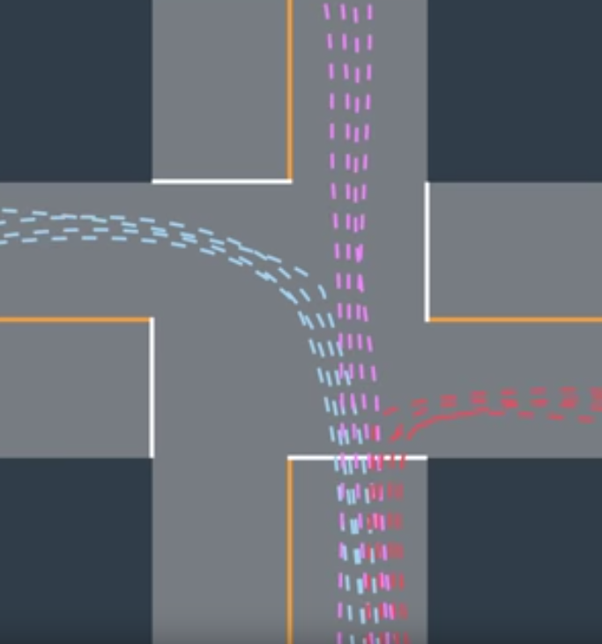

4. Perform unsupervised clustering

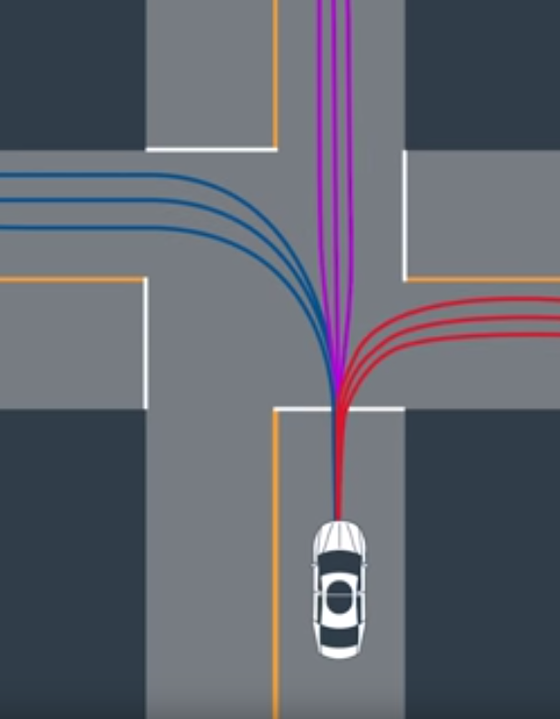

5. Define prototype trajectories for each cluster.

(In this image, we have 3 clusters, with 3 prototype trajectories for each cluster)

**LESSON 3.6: Data Driven Example: Trajectory Clustering/ON LINE**

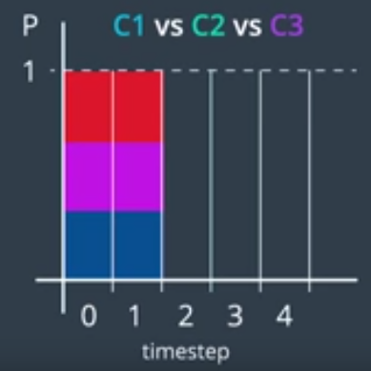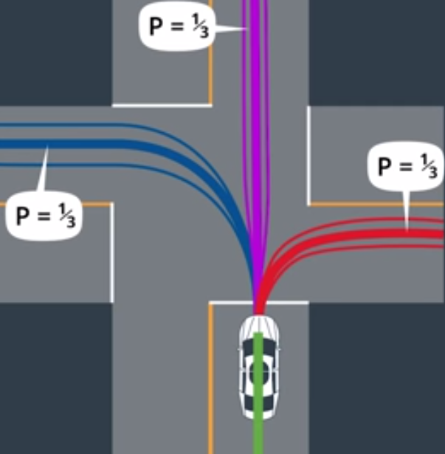ONLINE PREDICTION: Every update cycle...

1. Observe vehicle’s **partial trajectory**

2. Compare to **prototype trajectories**

3. Predict a trajectory (Probabilities!)

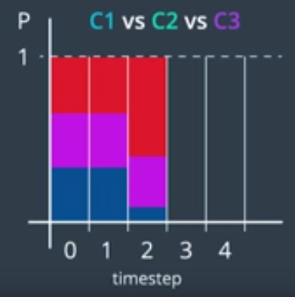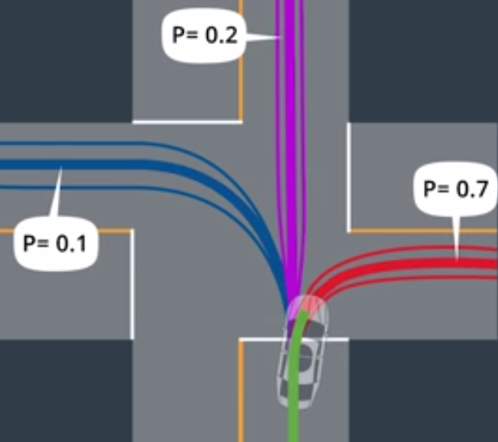

**LESSON 3.7: Model Based Approaches**

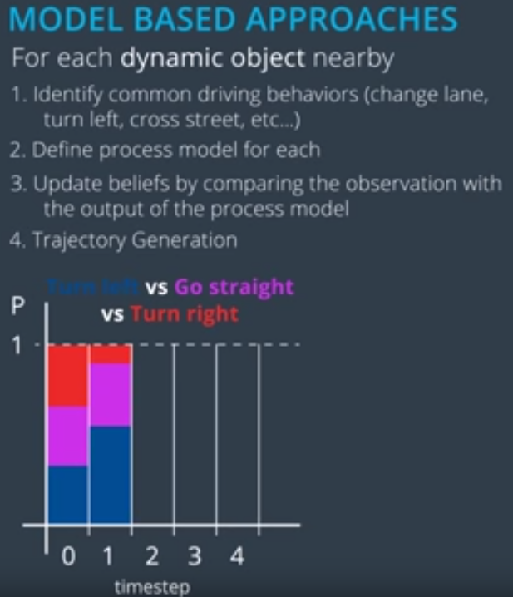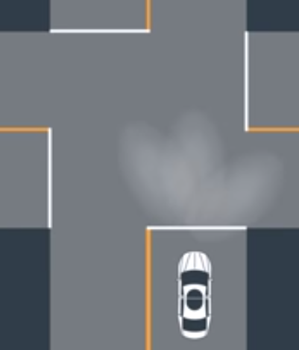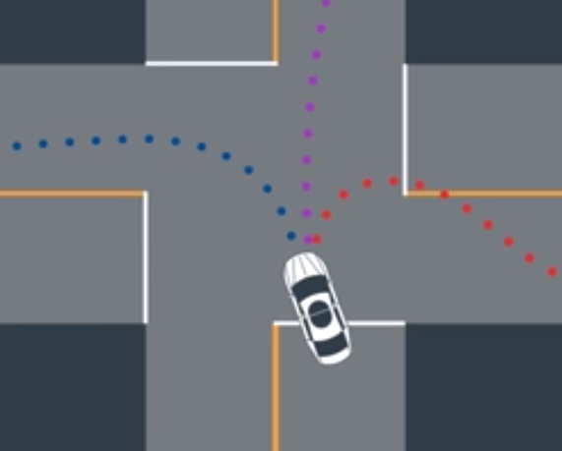

In step 3, **MULTI-MODAL ESTIMATION ALGORITHM** is used to maintain beliefs.

**LESSON 3.8: Frenet Coordinates**

*s* = distance along the road, or longitudinal displacement

*d* = side-to-side position on the road, or lateral displacement. (To the right is positive)

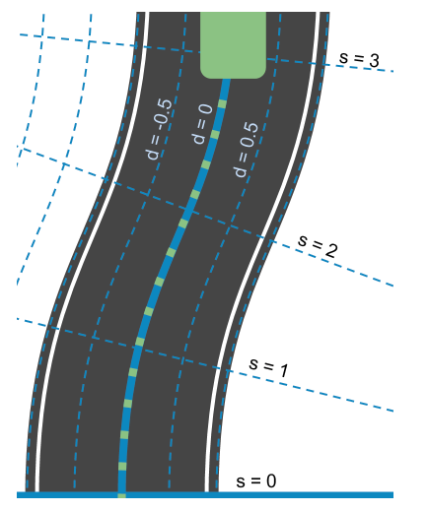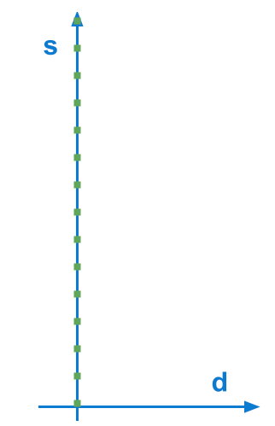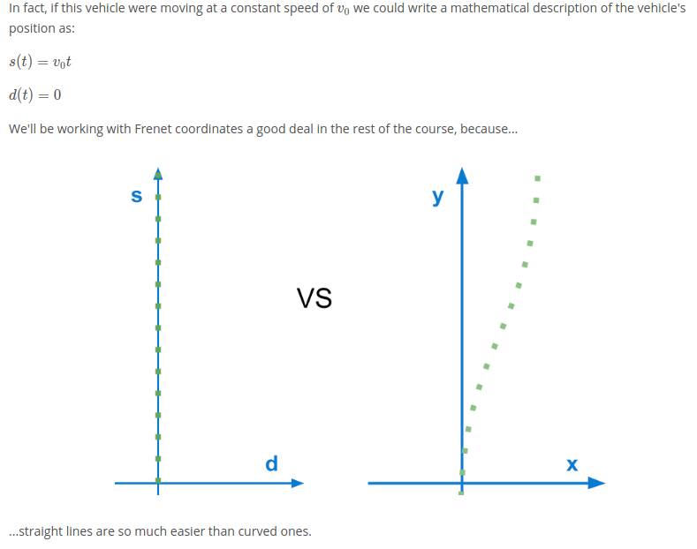

**LESSON 3.9: Process Models**

...not summarized a lot of the lessons… still to do…

there is a nice summary lesson (3.12 or 4.12)….

**LESSON 4: BEHAVIOR PLANNING**

The behavior planner is responsible for providing guidance to the trajectory planner about what sorts of maneuvers they should plan trajectories for.

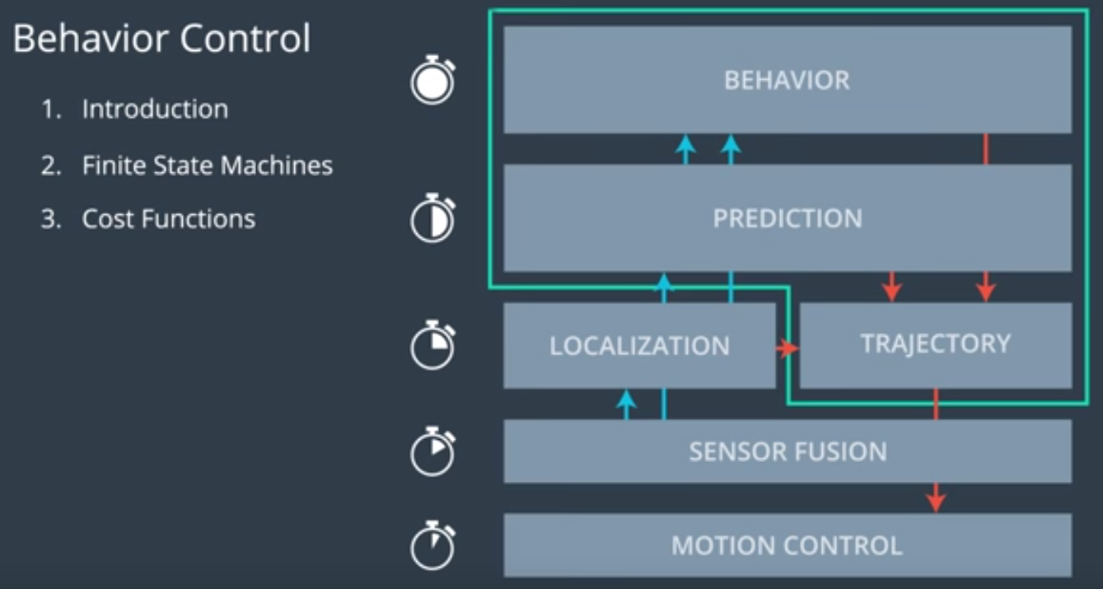

**LESSON 4.3-4.5: Finite State Machines (FSM)**

A Finite State Machine makes decisions based on a **finite set of discrete states**.

* It is initialized in a **start state** (S0).
* Any pair of states can be connected by one or more **transitions**.
* Sometimes there is a transition back to the same state, called a **self transition**.
* Some states do not transition to other states. These are called **accepting states**.
* Non-accepting states often have multiple successors. To decide which state to transition to next, the FSM needs some input and then use a **state transition function** to decide what state to go next.

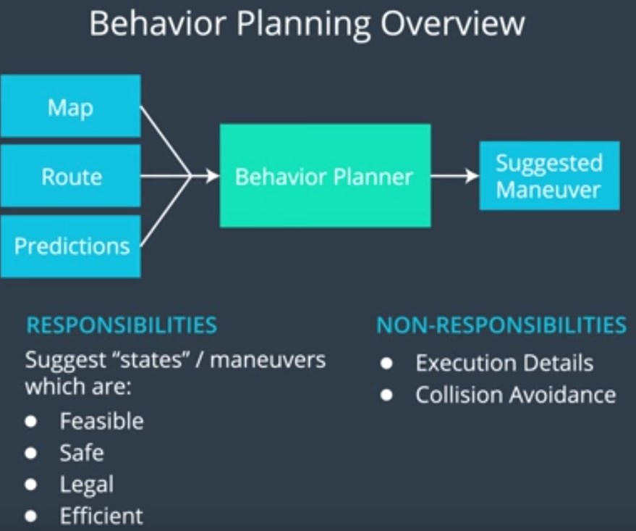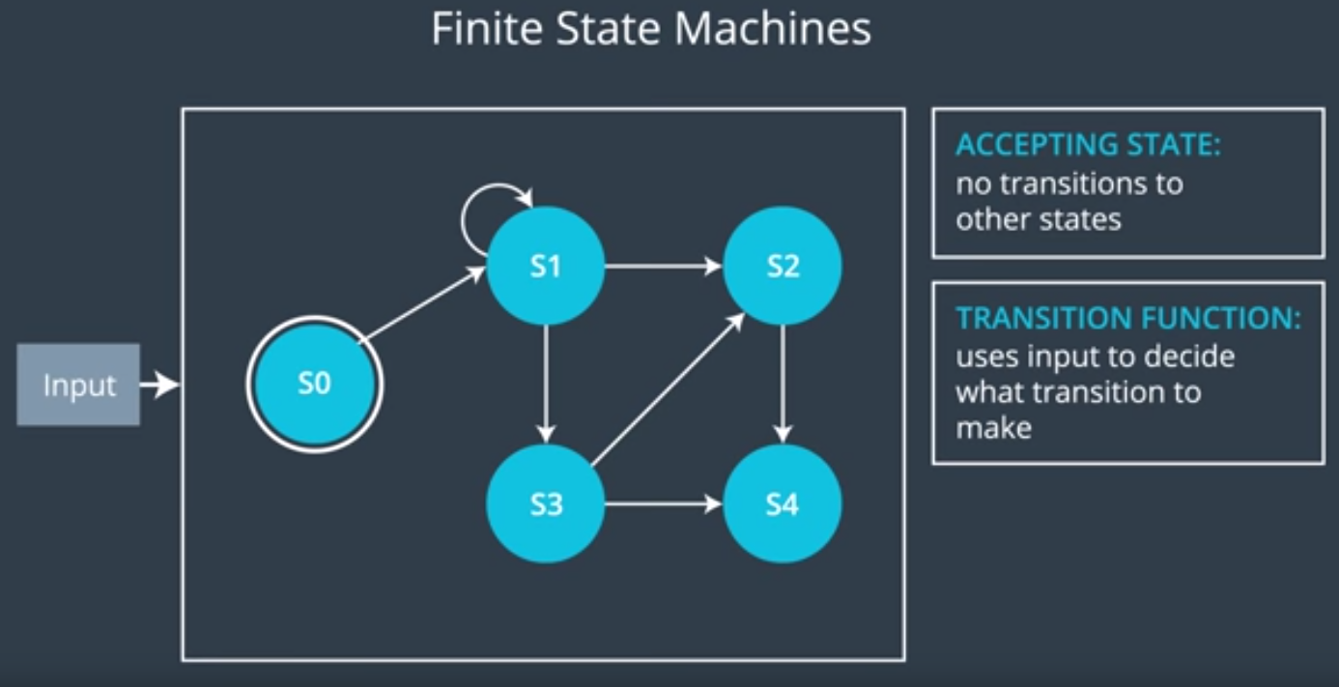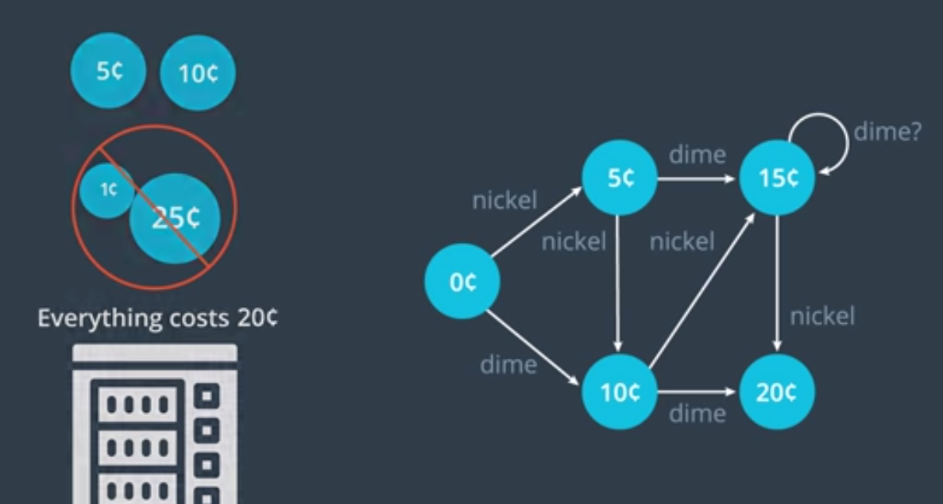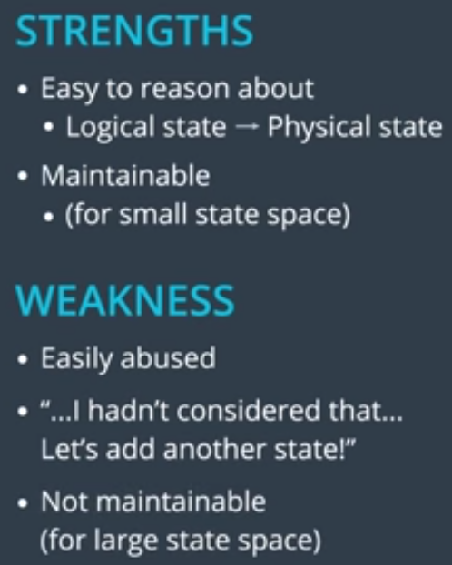

**LESSON 4.7-4.8: States for Self Driving Cars**

When focused on highway driving, following states make sense:

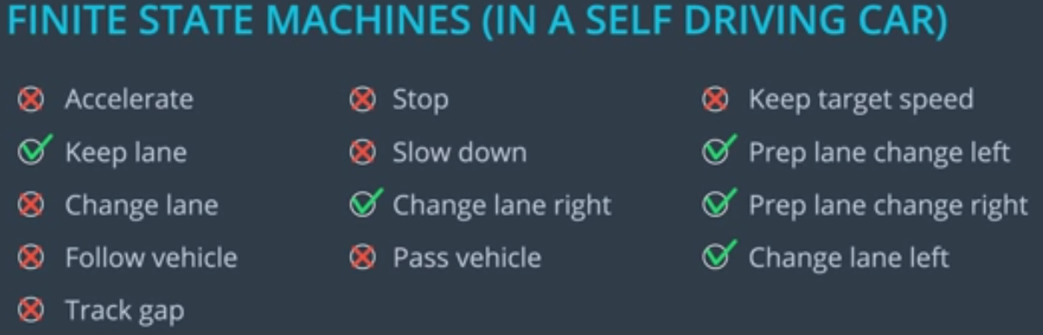

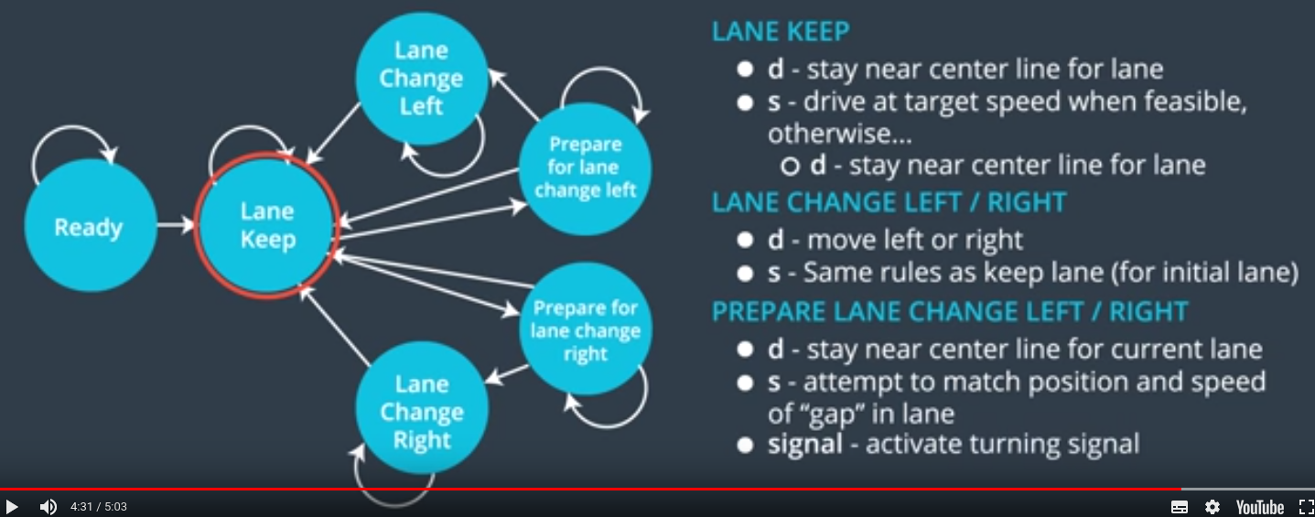

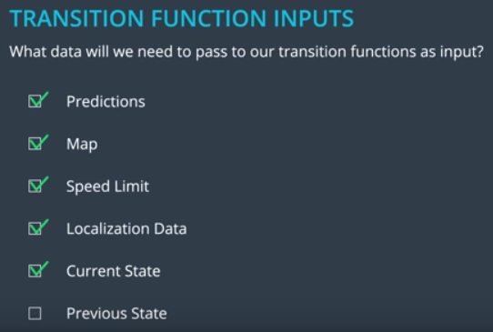**LESSON 4.9: Inputs to Transition Functions**

**LESSON 4.10: Transition Function pseudo code**

**def** **transition_function**(predictions, current_fsm_state, current_pose, cost_functions, weights):

*# only consider states which can be reached from current FSM state.*

possible_successor_states = successor_states(current_fsm_state)

*# keep track of the total cost of each state.*

costs = []

**for** state **in** possible_successor_states:

*# generate a rough idea of what trajectory we would*

*# follow IF we chose this state.*

trajectory_for_state = generate_trajectory(state, current_pose, predictions)

*# calculate the "cost" associated with that trajectory.*

cost_for_state = 0

**for** i **in** range(len(cost_functions)) :

*# apply each cost function to the generated trajectory*

cost_function = cost_functions[i]

cost_for_cost_function = cost_function(trajectory_for_state, predictions)

*# multiply the cost by the associated weight*

weight = weights[i]

cost_for_state += weight * cost_for_cost_function

costs.append({'state' : state, 'cost' : cost_for_state})

*# Find the minimum cost state.*

best_next_state = **None**

min_cost = 9999999

**for** i **in** range(len(possible_successor_states)):

state = possible_successor_states[i]

cost = costs[i]

**if** cost < min_cost:

min_cost = cost

best_next_state = state

**return** best_next_state

**LESSON 4.11: Create a Cost Function – Speed Penalty**

All cost functions have values between 0-1. The importance of different cost functions are defined by weights.

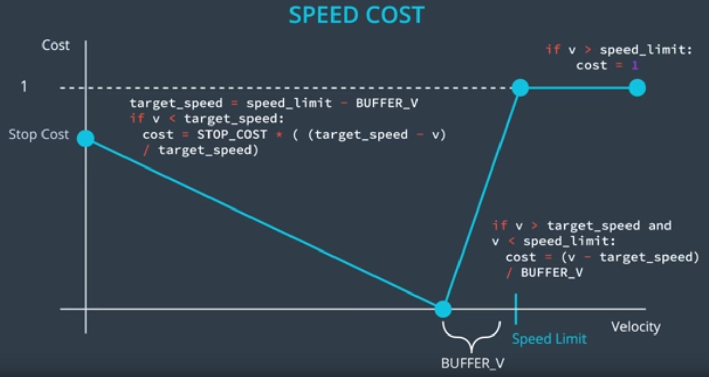

**LESSON 4.13: Cost Function Design and Weight Tweaking**

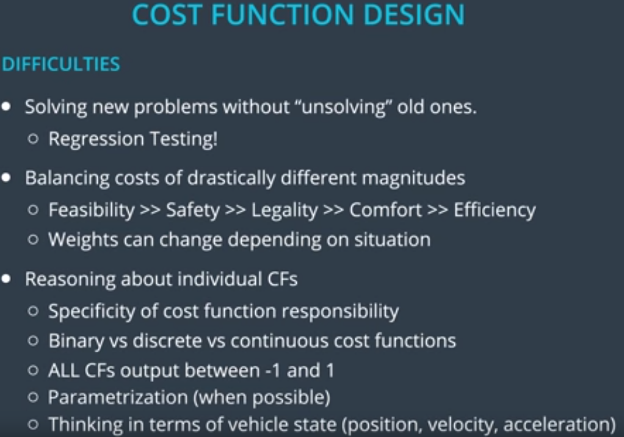

Create multiple cost functions for same feature (eg. SPEED) for different classes (Feasibility, Safety, Legality,…)

For example, 3 cost functions for speed:

1. **class = legality**: binary:

if speed < speed limit : 0

if speed > speed limit : 1

1. 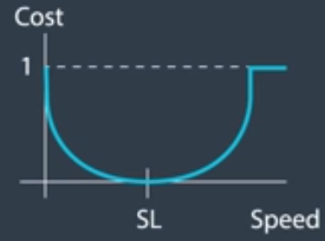**class = efficiency**: continuous, eg. a parabola that gives high cost to stopping, zero at speed limit. If it stays low over the speed limit, that is OK, because the cost function of class legality penalizes that:
2. **class = Safety**: speed ~= traffic speed (=speed of car in front).

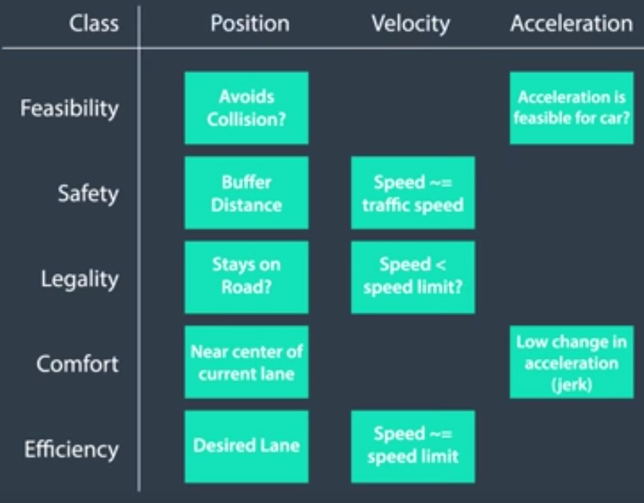Similar considerations for Position and Acceleration, with more cost functions for each class.

Based on different traffic situation, different weights are assigned to the cost functions.

Merging on highway → Assign high weights to these cost functions:

* Safety/Velocity ( Speed ~= traffic speed )
* Feasibility/Position ( Avoids Collision?)
* Safety/Position ( Buffer Distance )

**LESSON 4.14: Cost Function Matching**

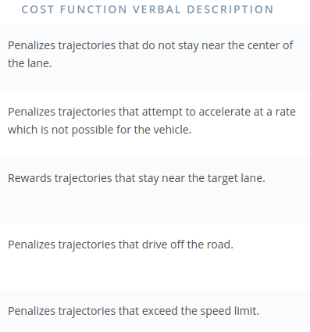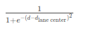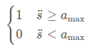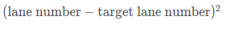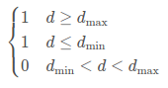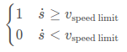

**LESSON 4.15: Scheduling Compute Time**

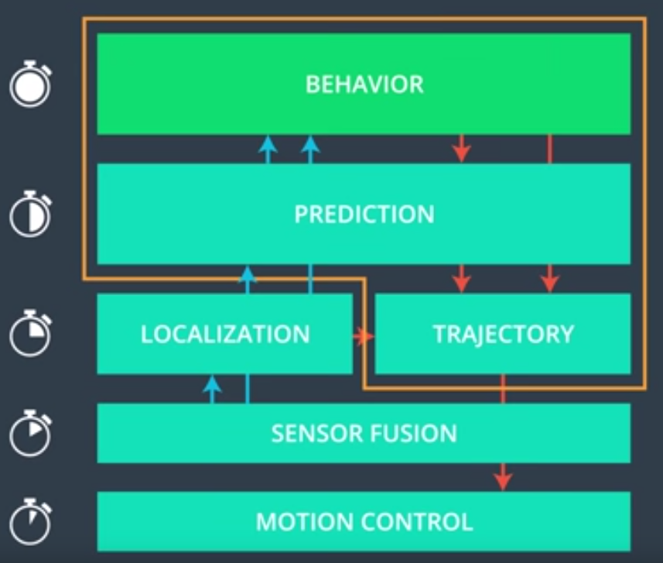

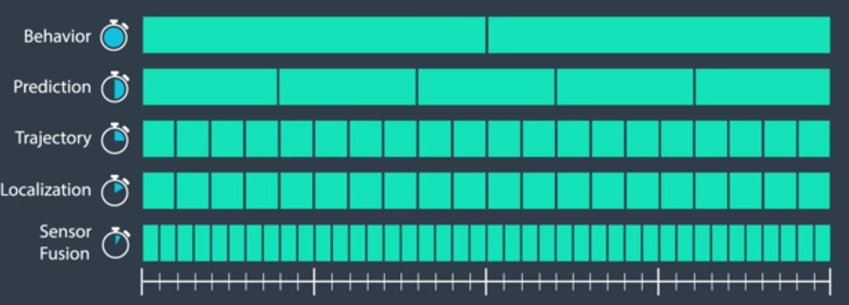

**LESSON 5.9: Hybrid A* vs A\***

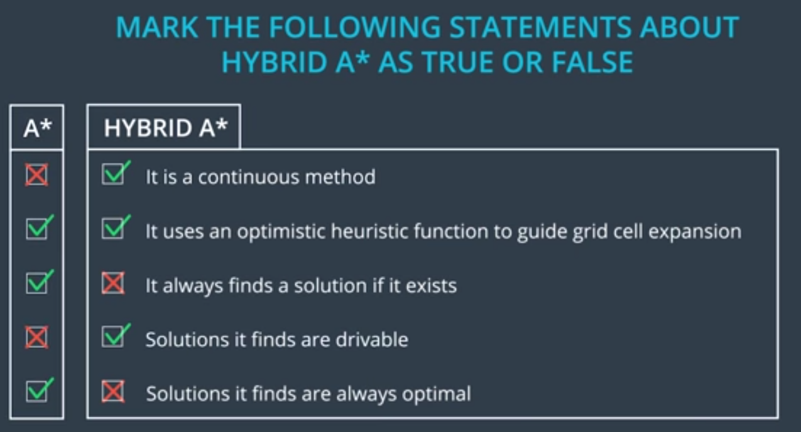

**LESSON 5.10: Hybrid A* in Practice**

Good motion model for car uses the bicycle model, with maximum steering angles and with a path assembled out of 3 components [straight, left, right]

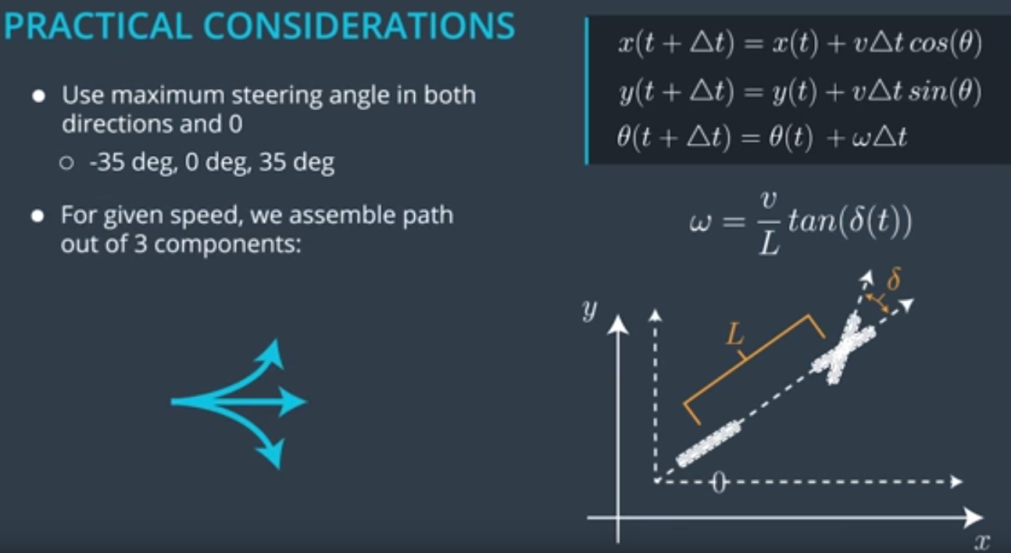

See video here: <https://classroom.udacity.com/nanodegrees/nd013/parts/6047fe34-d93c-4f50-8336-b70ef10cb4b2/modules/27800789-bc8e-4adc-afe0-ec781e82ceae/lessons/db4b83a1-b304-4355-92c7-66e973102079/concepts/3731a6e5-a5f3-4217-95f4-5d988244c5ad>

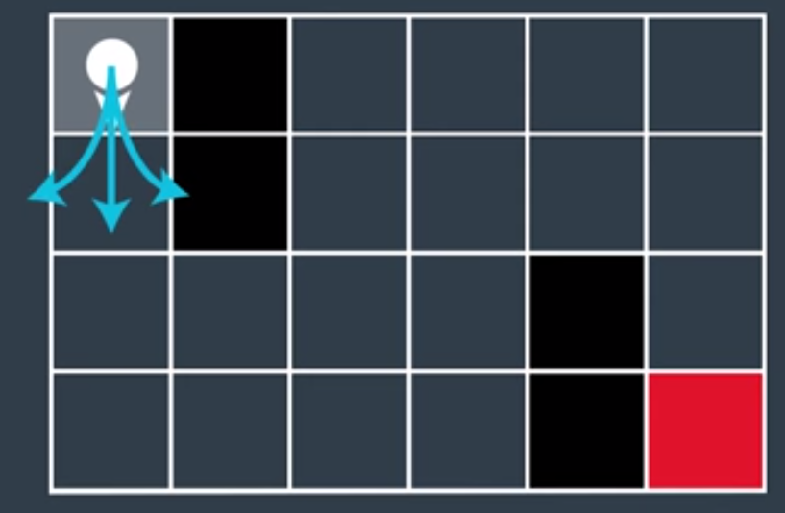

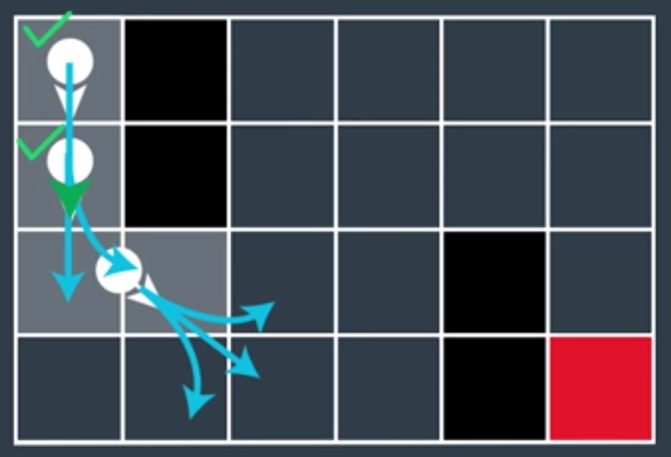

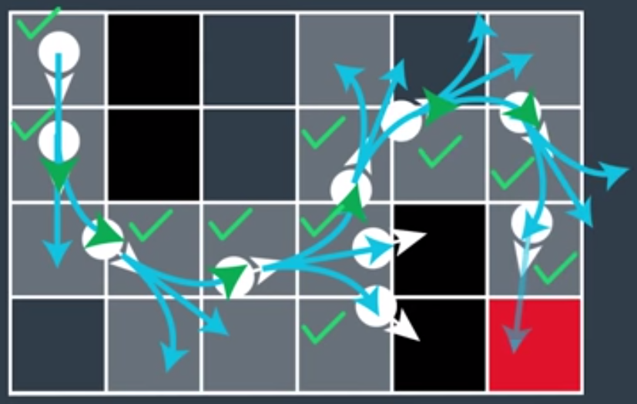

Read section 6.3 of paper: <https://d17h27t6h515a5.cloudfront.net/topher/2017/July/595fe838_junior-the-stanford-entry-in-the-urban-challenge/junior-the-stanford-entry-in-the-urban-challenge.pdf>

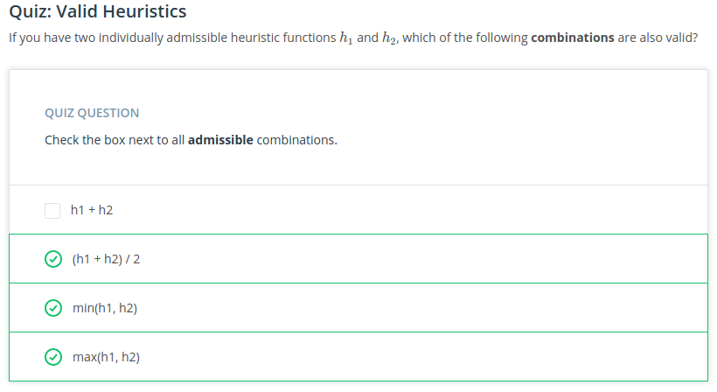

**LESSON 5.13: Environment Classification**

A* is good at finding a path everywhere in unstructured environments, but it does not take into account constraints or guidance in structured environments:

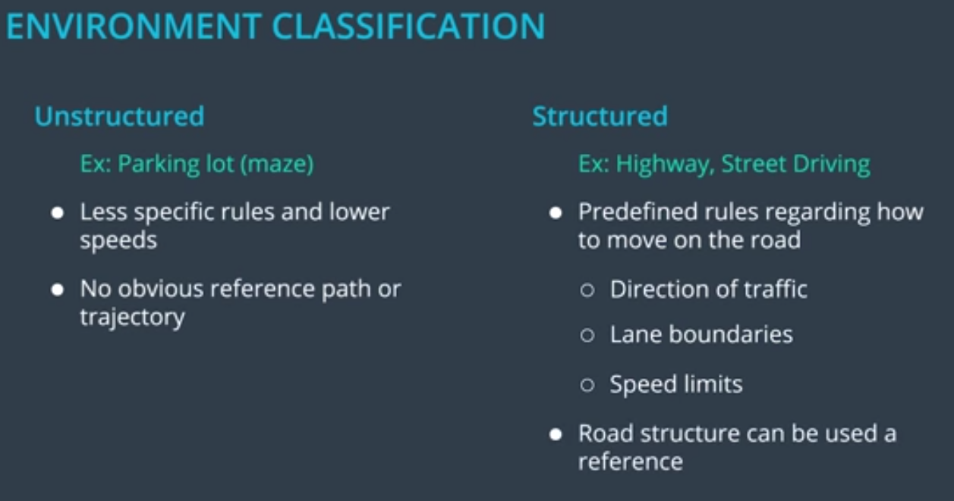

**LESSON 5.16: s, d, and t (for time!)**

Look at trajectory in s vs t and d vs t, to capture breaking, accelerating, stopping. It is no longer a **PATH**, it is now a **TRAJECTORY** !!!

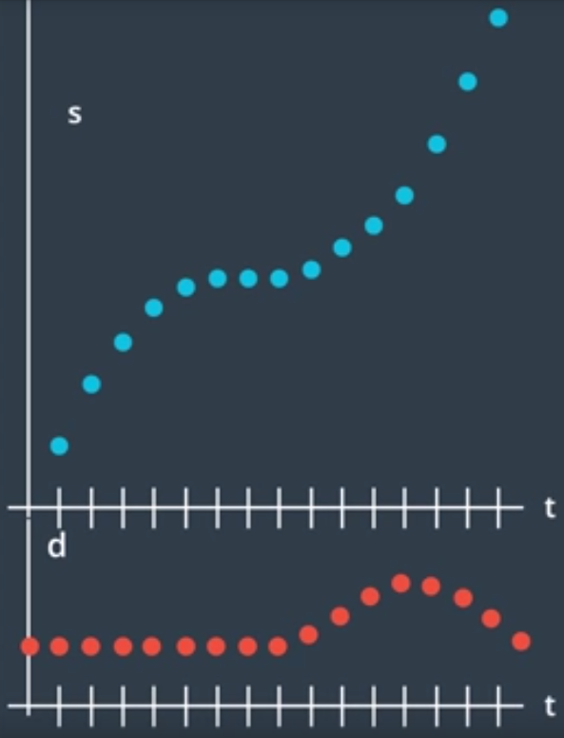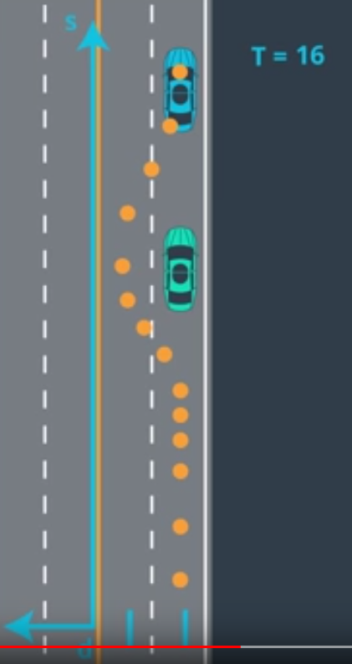

**LESSON 5.20: Jerk Minimizing Trajectories**

Humans are ok with high velocity and reasonably high accelerations, but NOT with rapidly changing accelerations, which is called JERK.

So, the trajectory planner must come up with jerk minimized trajectories!

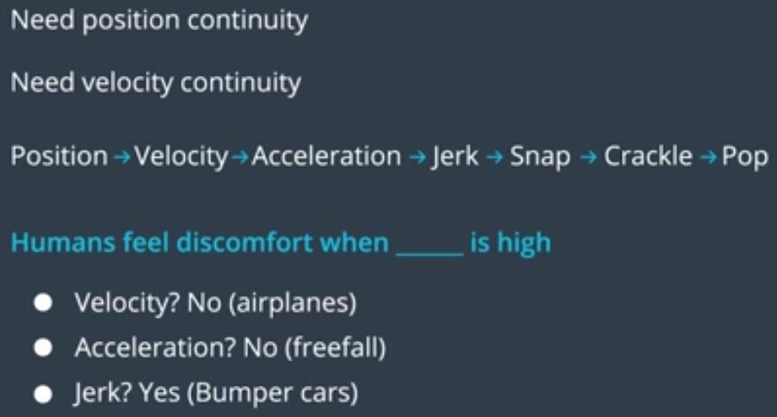

In 1D, all minimum jerk trajectories can be represented as a 5th order polynomial in time:

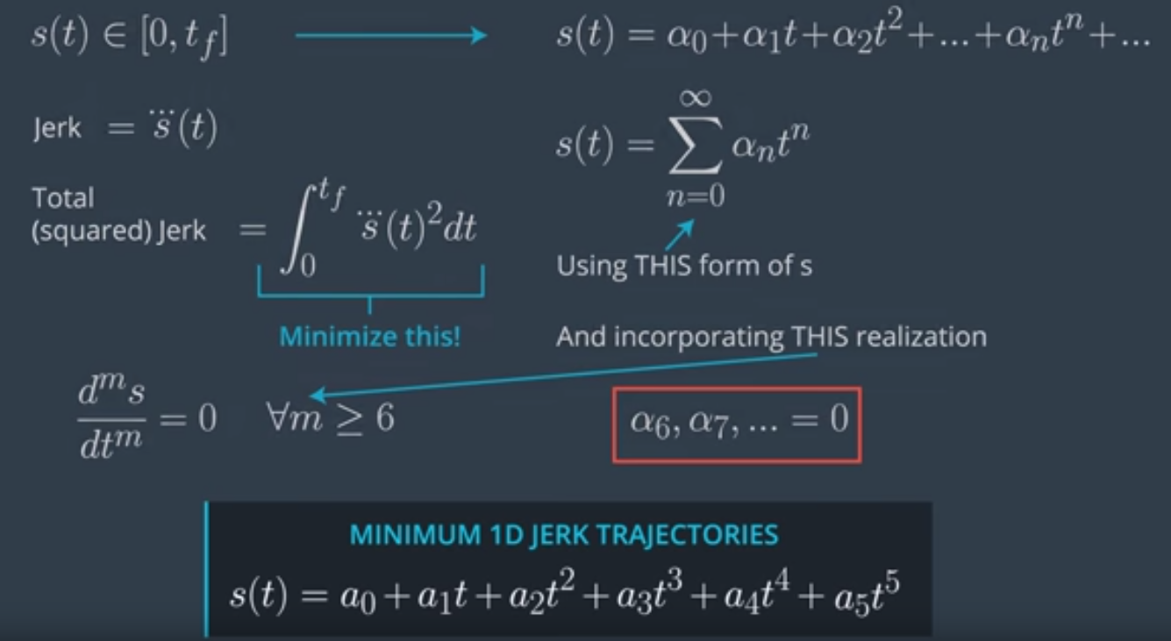

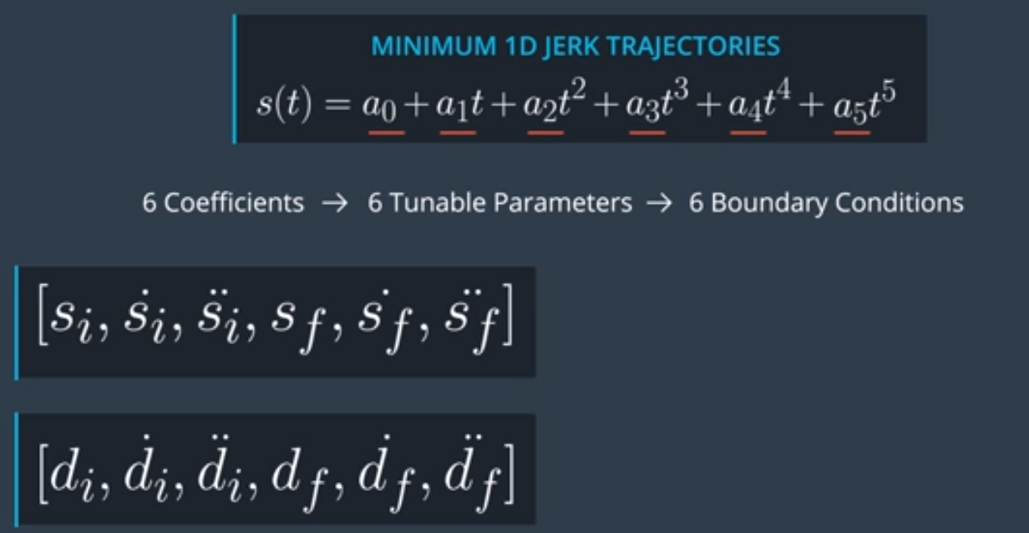

Can be rewritten in matrix notation:

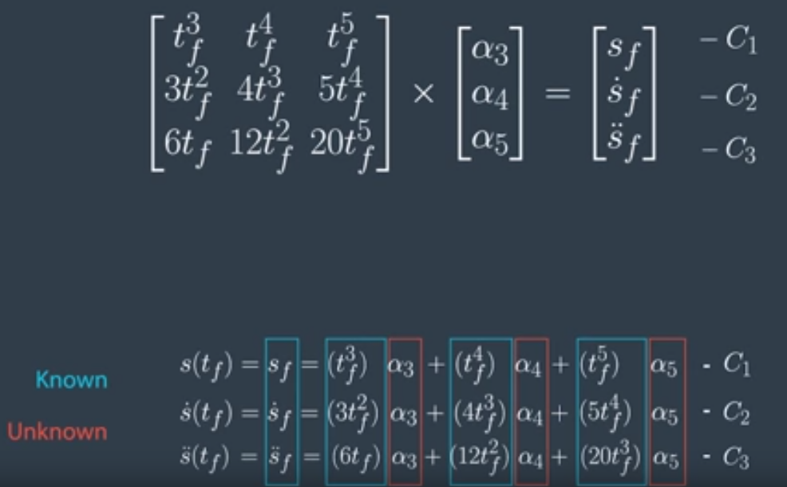

We will write a jerk-minimizing polynomial solver, which is then used for s and d, to get the coefficients of the jerked minimized trajectory for start state (i) & goal state (f) & duration (T):

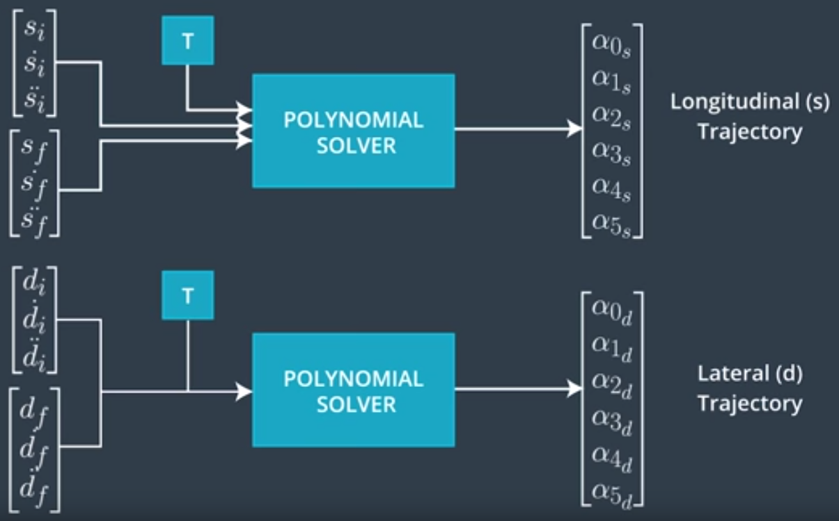

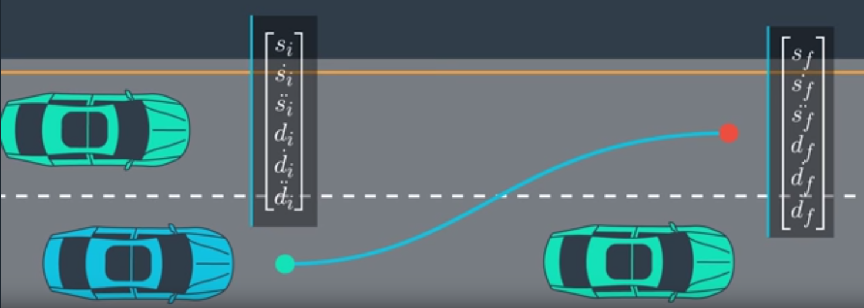

**LESSON 5.26 & 5.27: Feasibility checks on calculated Trajectories**

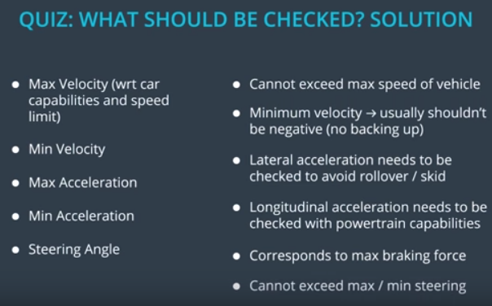

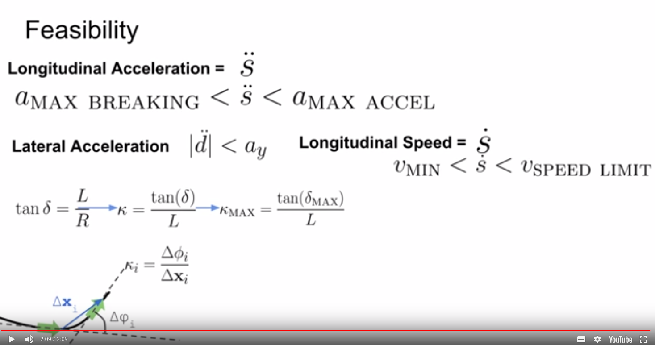

NOTE: *K* = curvature of trajectory; delta=steering angle.

**LESSON 5.28: Putting it all Together**

* 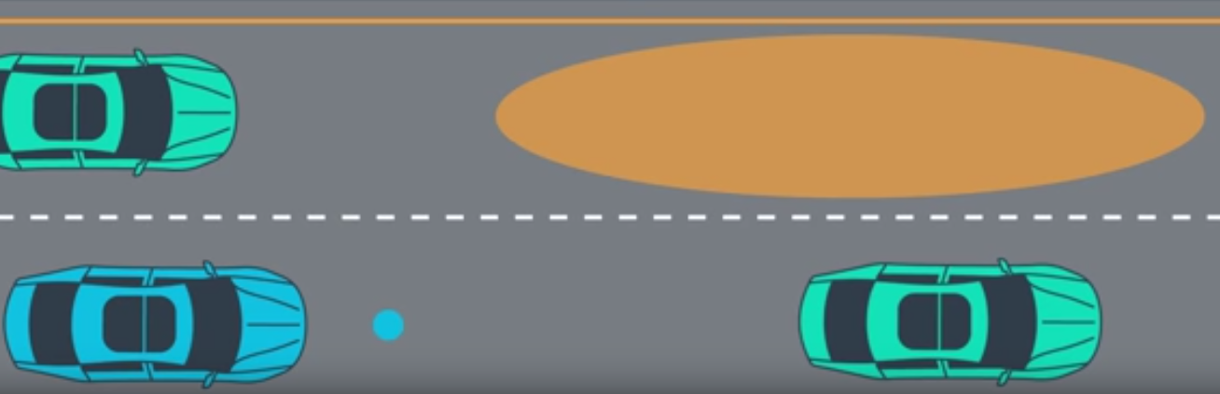Behavioral Layer gives a goal regions to end up after a certain duration.
* 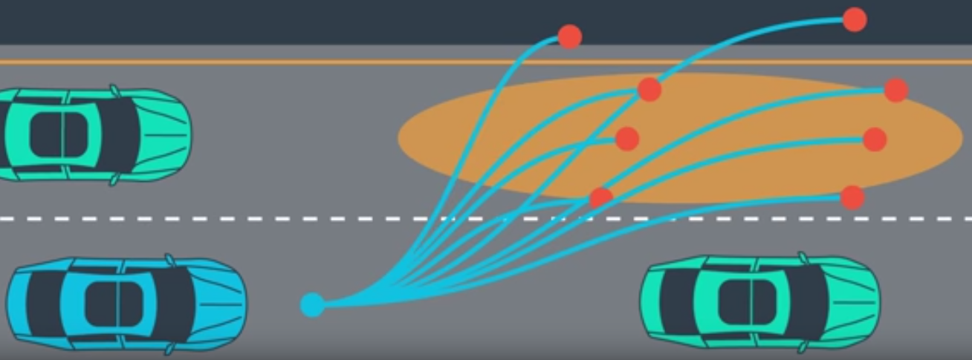We create large number of jerk minimized trajectories.
* 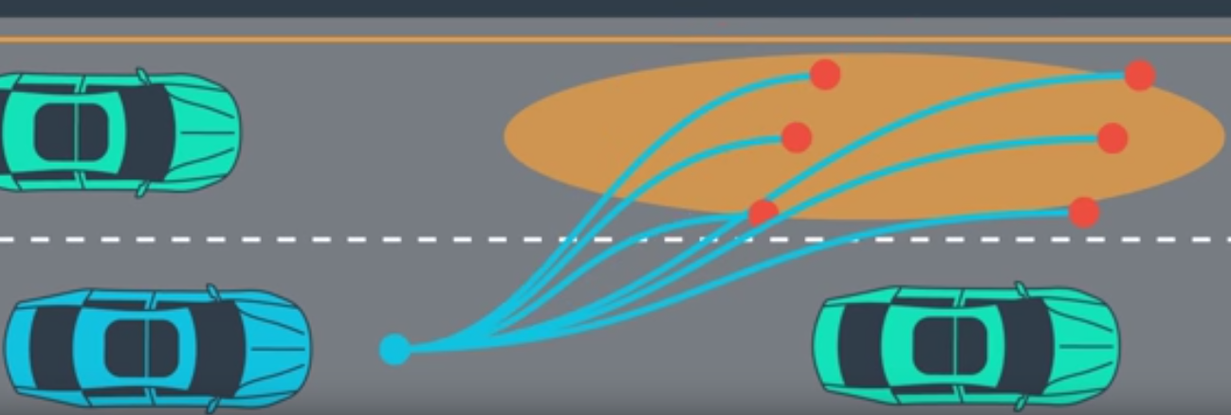We throw away all trajectories that would lead to driving off the road or collisions with other cars or pedestrians.
* Then, the remaining trajectories are ranked with a cost function, that takes into account:
  + Jerk
    - Lateral Jerk (Jd) vs. Longitudinal Jerk (Js) (Lateral Jerk is much more uncomfortable)
  + 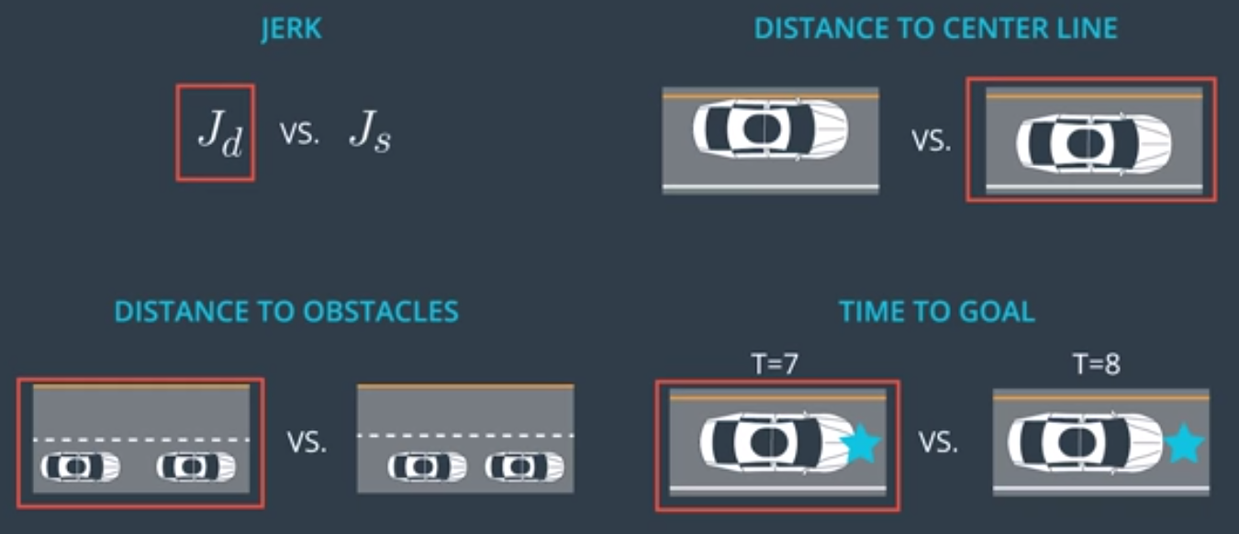Distance to Obstacles
  + Distance to center line
  + Time to Goal

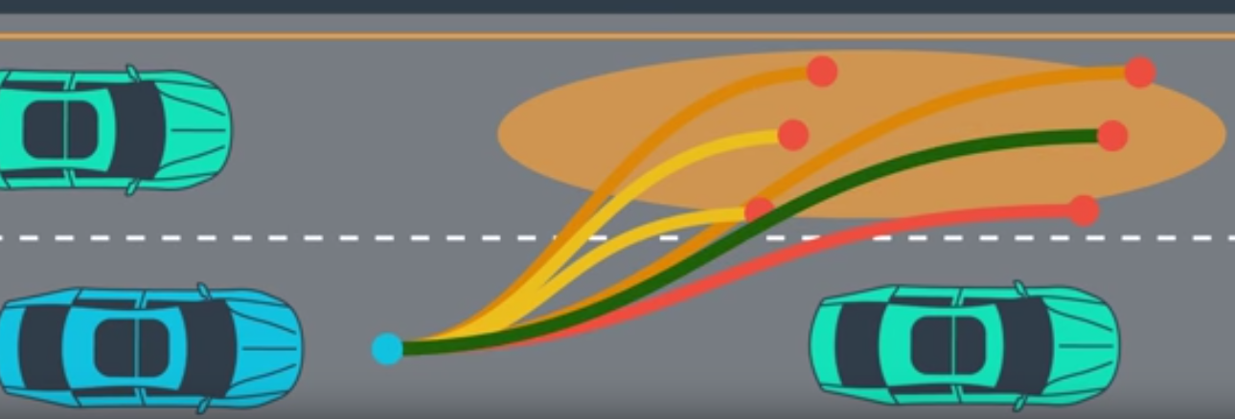

* The trajectory with lowest cost wins

**LESSON 5.29: Additional reading on Polynomial Trajectory Generation**

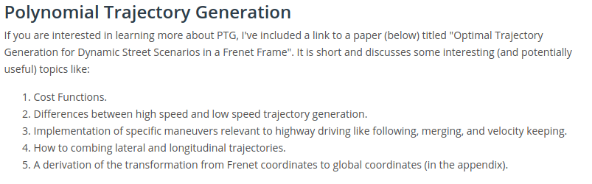

<https://d17h27t6h515a5.cloudfront.net/topher/2017/July/595fd482_werling-optimal-trajectory-generation-for-dynamic-street-scenarios-in-a-frenet-frame/werling-optimal-trajectory-generation-for-dynamic-street-scenarios-in-a-frenet-frame.pdf>

Includes description of transformation from Frenet to global coordinates !